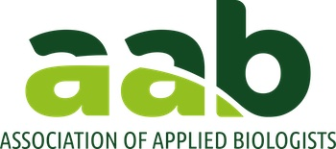

Travel Grant Application Form for Plant Science Education II conference

The grants are available to anyone attending the Plant Science Education II conference.
Preference will be given to applications from early career professionals (ECPs) but however this award is not exclusive to ECPs.
Grants are restricted to cover accommodation, standard class flights, rail or bus fares (using a rail card if available). All grants are discretionary.
Applications must be made at least 2 months before the meeting to the AAB Executive Officer Geraint Parry at geraint@aab.org.uk. The application will be assessed by the conference organising committee.
Payments will be made on submission of receipts after the event but on rare occasions up-front payments are possible if deemed essential by the conference organising committee. The maximum value for each application is £500 per person.

At their earliest convenience each awardee will be required to provide short report (~500 words) for publication in the AAB newsletter and other related outputs.

Name:

Email Address:

Current position:

Estimated costs (£) with details:

Why would you like to attend this meeting (<200 words):

